Pseudocode

A <= array

data <= value to be searched

Found = 0

min = 0

max = 31

while min >= max do

mid = (min + max)/2

if A[mid] < data then

min = mid + 1

end if

if A[mid] > data then

max = mid - 1

end if

if A[mid] = data then

Found = 1

break

end if

end while

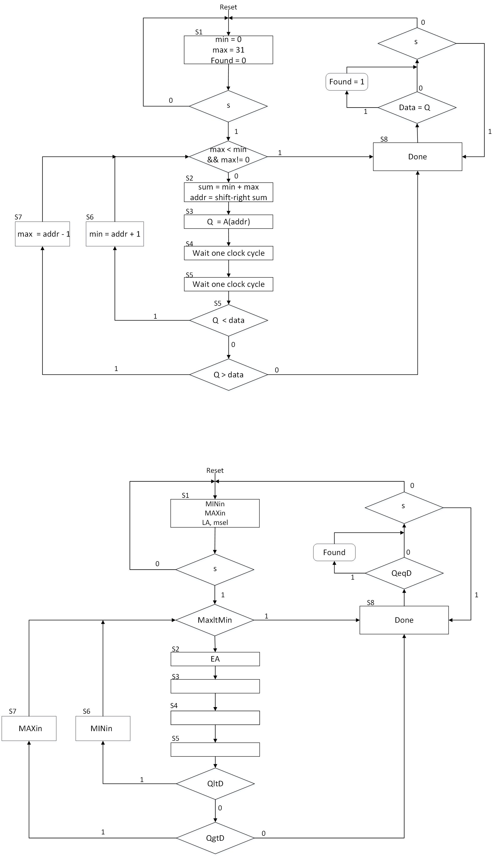ASM chart

Data path

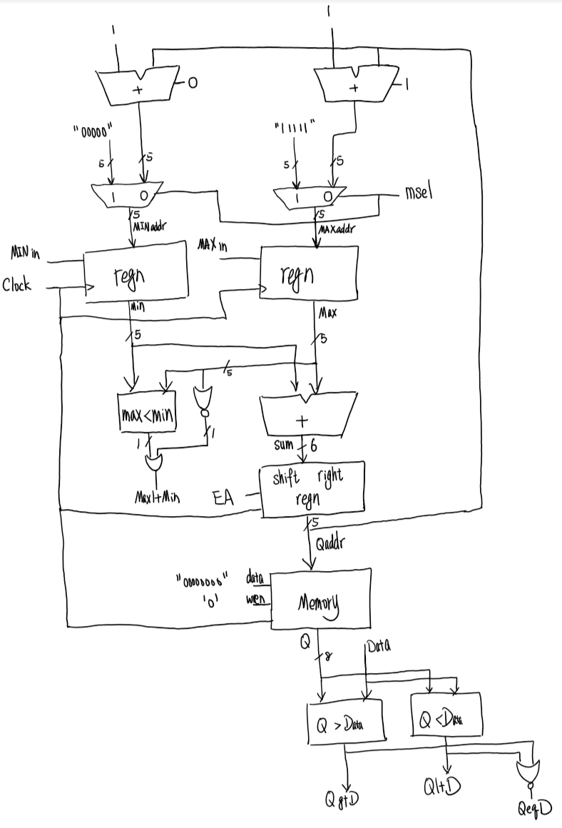

ASM chart with the names of the signals

